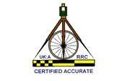

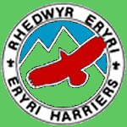

BORDERS ROAD RUNNING LEAGUE
Trac Môn, Anglesey
Sunday 6th December 2026, 11:00
from A55 junction 5 (satnav postcode LL63 5TF)
Under UK Athletics Rules:
UKA License No: 26RRWA00415
Course measurement Certificate No. 18/593

Parking

Parking for runners and spectators is in the main Trac Môn carpark, LL63 5TF. Please follow marshals’ instructions/signs. https://www.angleseycircuit.com/
Please note
No animals are permitted anywhere on the site
No Drones, as the site is a no-fly area

The start and race HQ are next to the car park.

Enquiries

The enquiry desk / Race HQ will be down stairs in the Race Control Building in the competitor’s sign in room.
NOTE: Minimum age 15 years on day of the race.

Changing

Male and Female changing, showers and toilets are situated by the car park area.

Catering

The Circuit Café will be open for refreshments

The Course – Measured 5 Miles

The start will be just on the top bend with the route running around the circuit in an anticlockwise direction heading down to the finish line, then bearing left by the pits and heading back up to the start (Green Lap on plan), then there will be two full circuits of the relatively flat track with the finish in front of the pits on the tracks official finish line. Map of route is below and will be displayed near the Enquiries Desk.

During the Race

Obey marshals’ instructions at all times.
UK Athletics Rule 240 S5 Bars Headphones plugged into ears and are not permitted in open road races. Bone conductor sports headphones are the only headphones approved for use in all road races under the UK Athletics rules of competition.
Anyone wearing plugged in headphones will be disqualified from the race.

The course will be marshalled, and the circuit will be closed to traffic for the duration of the event.

A water station is situated at the finish line. Medical cover will be provided by Trac Môn.

If you have Club flags please bring them so that we can line the pit wall

Acknowledgements

We wish to thank Kevin Clark and Cybi Striders for allowing Eryri the use of their Borders league Race venue and all those who support us in staging this race. These include:
- Marshals and many others helping to stage the race.
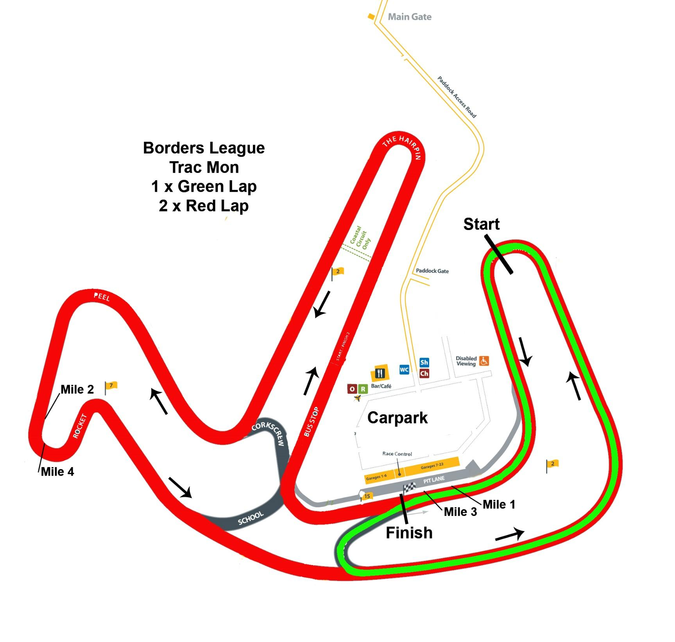
- Anglesey Circuit Trac Môn for the use of their facilities and assistance with car parking arrangements

